**GGPLOT in class Assignment**

|  |  |
| --- | --- |
| **Student Name** | Mazaharuddin Mohammad |
| **Student Number** | N01464978 |
| **Subject Name** | [Big](https://learn.humber.ca/webapps/blackboard/execute/courseMain?course_id=_187043_1) data 2 |
| **Professor Name** | Orren Johnson |

Print both charts when done onto a word document with your name and student id and submit using the mtcars inbuilt dataset

1. **Draw a bar graph, that shows the number of each gear type in mtcars , with a subset of carb greater or equal to 3, also make sure you show the count.**

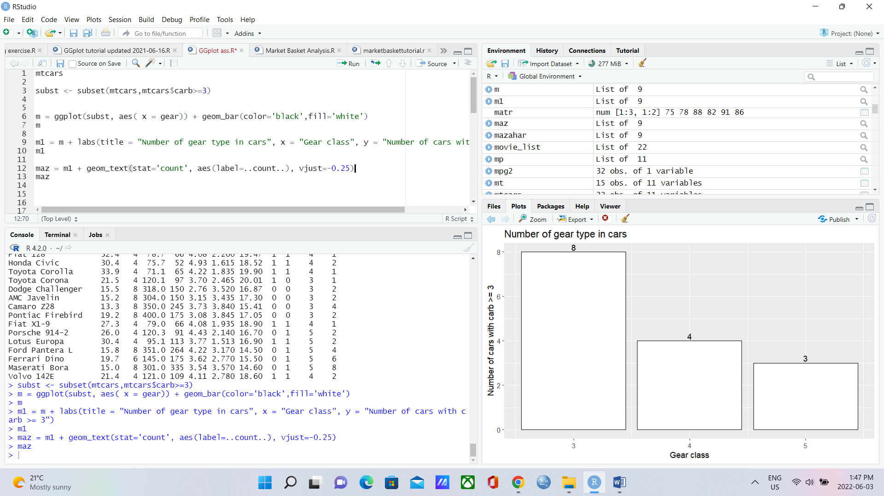

**Code:**

mtcars

subst <- subset(mtcars,mtcars$carb>=3)

m = ggplot(subst, aes( x = gear)) + geom_bar(color='black',fill='white')

m

m1 = m + labs(title = "Number of gear type in cars", x = "Gear class", y = "Number of cars with carb >= 3")

m1

maz = m1 + geom_text(stat='count', aes(label=..count..), vjust=-0.25)

maz

1. **Draw a stacked bar graph of the number of each gear type and how they are further divided out by cyl – clue think of the fill=factor**

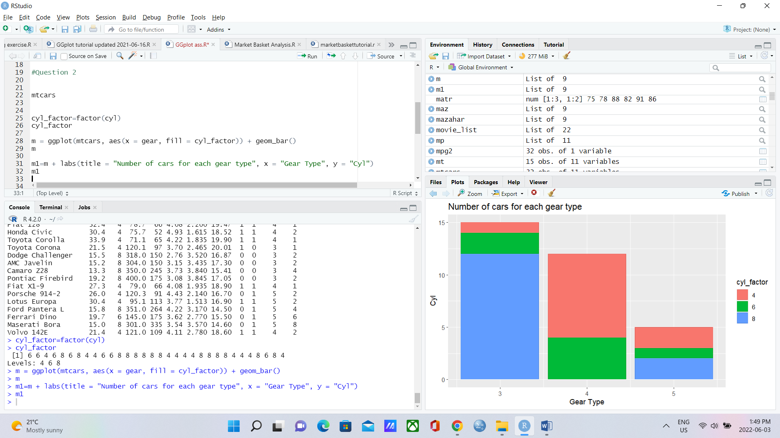

**Code:**

mtcars

cyl_factor=factor(cyl)

cyl_factor

m = ggplot(mtcars, aes(x = gear, fill = cyl_factor)) + geom_bar()

m

m1=m + labs(title = "Number of cars for each gear type", x = "Gear Type", y = "Cyl")

m1